Cottingham Parish Council

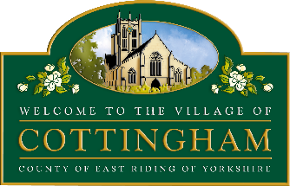

To Members of the Cottingham Parish Council 17th December 2025
Planning Committee

Dear Councillor

PARISH COUNCIL PLANNING COMMITTEE MEETING

I hereby summon you to attend the next meeting of the Cottingham Parish Council Planning Committee which will be held at The Parish Council Office, 9 The Cottages, Market Green, Cottingham, at 7pm, on Tuesday 6th January 2026. I have attached a list of Notices of Decision and Applications for your information. The meeting will be available to view via Microsoft Teams Meeting ID: 359 575 869 569 37 Passcode: iv2w8T8r

Parish Council Planning meetings are held in public, they are not public meetings. Members of the public are welcome to attend meetings as observers only, however, at the Chair's discretion, residents may be permitted to comment on a specific planning application. It should be noted that the Parish Council is one of many Planning consultees and East Riding of Yorkshire Council makes the final decision. Members of the Public can post comments directly onto East Riding of Yorkshire Council Planning Portal by visiting their website

Nicola Pape
Nicola Pape, Clerk to Cottingham Parish Council

The Business to be transacted is as follows:

- Declarations of interest

- To receive and approve apologies

- To receive Notices of Decision (see attached sheet)

- To consider Planning Applications outstanding since the date of the last Meeting

- To receive update on the proposed installation of speed indicator devices

- To consider the proposed changes to on street waiting restrictions, Castle Hill estates

- To consider response to the Electric Vehicle Charging Changes to Permitted Development Rights consultation

- To consider Planning Appeal 25/00109/ADVERT, Display of intermittent internal digi-screen set back from shopfront glazing, Specsavers, 92 King Street, Cottingham

- Items for the next agenda (Discussion items only)

