Cottingham Parish Council

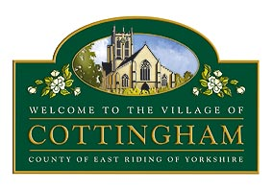
Members of the Cottingham Parish Council
Finance Committee

30th October 2025
Dear Councillor,

FINANCE COMMITTEE MEETING
I hereby summon you to attend the next meeting of the Cottingham Parish Council Personnel Committee to be held at 6.00pm on Thursday 6th November 2025 at the Parish Council offices, 9 The Cottages, Market Green, Cottingham. MEETINGS ARE OPEN TO MEMBERS OF THE PUBLIC AND CAN BE JOINED REMOTELY VIA MICROSOFT TEAMS using Meeting ID: 375 581 153 531 2Passcode: LE6Kx3AZ
Nicola Pape
Nicola Pape
Clerk to the Cottingham Parish Council
The Business to be transacted is as follows:
- Declarations of Interest
  - To record declarations of interest by any member of Council in respect of the agenda items listed below. Members declaring interests should identify the agenda item and type of interest being declared.
  - To note dispensations given to any member of the Council in respect of the agenda items listed below

- To receive and approve apologies

3. To receive update on the financial position of the Council, review budget, and review October payments

4. To consider the budget update for 2025/26 and make recommendations on any virements required

5. To consider budget requests for inclusion in a proposed budget for 2026/27

6. To review the risks relating to Finance/General Administration

7. Members’ points of information and agenda items for the next meeting (Discussion items only) and to set date for next meeting.

