Cottingham Parish Council

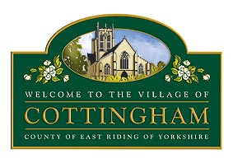

To Members of the Cottingham Parish Council 30th July 2025

Planning Committee

Dear Councillor

### PARISH COUNCIL PLANNING COMMITTEE MEETING

I hereby summon you to attend the next meeting of the Cottingham Parish Council Planning Committee which will be held at **The Parish Council Office, 9 The Cottages, Market Green, Cottingham**, at **7pm**, on **Tuesday 5th August 2025**. I have attached a list of Notices of Decision and Applications for your information.

**The meeting will be available to view via Microsoft Teams Meeting ID:** 344 373 077 182 **Passcode:** T5kLDX

Parish Council Planning meetings are held in public, they are not public meetings. Members of the public are welcome to attend meetings as observers only, however, at the Chairman's discretion, residents may be permitted to comment on a specific planning application. It should be noted that the Parish Council is one of many Planning consultees and East Riding of Yorkshire Council makes the final decision. Members of the Public can post comments directly onto East Riding of Yorkshire Council Planning Portal by visiting their website.

Nicola Pape

Nicola Pape, Clerk to Cottingham Parish Council

The Business to be transacted is as follows:

1. Declarations of interest
2. To receive and approve apologies
3. To receive correspondence & Notices of Decision (see attached sheet)
4. To consider Planning Appeal 25/00060/REFUSE - 30 Eppleworth Road, Cottingham
5. To consider Planning Applications outstanding since the date of the last Meeting (see attached sheet)
6. To propose additional names to be added to the Cottingham street name bank
7. To discuss areas to be considered for a speed data survey request
8. To receive update on speed indicator devices information storage
9. To discuss the succession of roadworks in the village
10. Items for the next agenda (Discussion items only)