Cottingham Parish Council

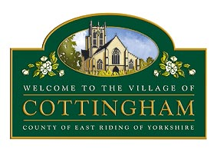

To Members of the Cottingham Parish Council
31st July 2025

Dear Councillor,

Extraordinary Meeting of the Parish Council

I hereby summon you to attend an Extraordinary Meeting of the Parish Council, which will be held at the Parish Council Office, 9 The Cottages, Cottingham at 6.00pm on 6th August 2025. MEETINGS ARE OPEN TO MEMBERS OF THE PUBLIC AND CAN BE JOINED REMOTELY VIA MICROSOFT TEAMS Meeting ID: 339 236 229 887 2 Passcode: xg6Zc6U6
Julia Marten
Chairman of Cottingham Parish Council

All mobile phones and other electronic devices should be switched to mute and only used to facilitate this meeting. The public are welcome to attend but are only permitted to speak with the Chair’s permission. Parish Council Meetings are meetings held in public, not public meetings.

The Business to be transacted is as follows:

1. Declarations of Interest

1.1 To record declarations of interest by any member of Council in respect of the agenda items listed below. Members declaring interests should identify the agenda item and type of interest being declared.
1.2 To note dispensations given to any member of the Council in respect of the agenda items listed below

2. To receive & approve apologies

3. To consider scale of charges for Cottingham Christmas Festival 2025 traders

4. To consider wording of BMX track signage/BMX track public survey questionnaire

5. To agree installation of Wi-Fi and purchase of laptop for CCTV monitoring

