Cottingham Parish Council

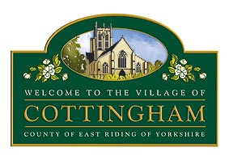

PERSONNEL COMMITTEE MEETING
HELD AT COTTINGHAM PARISH COUNCIL OFFICES, 9 THE COTTAGES,
MARKET GREEN, COTTINGHAM
AT 10:00am TUESDAY 9th APRIL 2024

M I N U T E S

Present: Clerks: Pape & Price
There were no members of the public present.

Apologies had been submitted from Cllrs Cantrell, Kemp, Marten and Ward

As no members were in attendance the meeting was closed at 10.05am

