Cottingham Parish Council

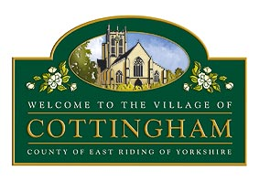

To Members of the Cottingham Parish Council
5 December 2023
Dear Councillor,

Extraordinary Meeting of the Parish Council

I hereby summon you to attend an Extraordinary Meeting of the Parish Council, which will be held at the Parish Council Office, 9 The Cottages, Cottingham at 7.30pm on Tuesday 12th December 2023. MEETINGS ARE OPEN TO MEMBERS OF THE PUBLIC AND CAN BE JOINED REMOTELY VIA MICROSOFT TEAMS Meeting ID: 326 989 841 601 Passcode: P9Hh4y
Nicola Pape

Nicola Pape, Clerk to Cottingham Parish Council

All mobile phones and other electronic devices should be switched to mute and only used to facilitate this meeting. The public are welcome to attend but are only permitted to speak with the Chair’s permission. Parish Council Meetings are meetings held in public, not public meetings.

The Business to be transacted is as follows:

1. Declarations of Interest

1.1 To record declarations of interest by any member of Council in respect of the agenda items listed below. Members declaring interests should identify the agenda item and type of interest being declared.
1.2 To note dispensations given to any member of the Council in respect of the agenda items listed below

2. To receive & approve apologies

3. To consider the purchase of Audio-visual equipment to improve the quality of streamed meetings

4. To consider the upgrade of IT equipment and support

5. To agree a policy for the use of Council debit cards

6. To agree a budget for snow and ice clearance for 2023/24

