Cottingham Parish Council

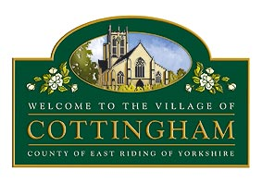
ANNUAL PARISH MEETING
HELD AT COTTINGHAM PARISH COUNCIL
AT 6.00pm THURSDAY 18TH MAY 2023

MINUTES

PRESENT Chairman – Cllr Abel

Clerks: Pape/Price
19 Members of the Public in attendance/1 Member of the Public via Zoom

- TO APPOINT A CHAIRPERSON OF THE ANNUAL PARISH MEETING (IF THE CURRENT CHAIR OR DEPUTY CHAIR ARE ABSENT)

Cllr Abel, Chairman of the Parish Council, was in attendance and chaired the meeting.

- TO RECEIVE APOLOGIES

There were no apologies.

- TO READ AND ADOPT THE MINUTES OF THE PARISH MEETING HELD ON THURSDAY 19th MAY 2022

Resolved: That the minutes of the meeting held on 19th May 2022 be adopted

- TO RECEIVE THE REPORT OF THE CHAIRMAN OF THE PARISH COUNCIL

The Chairman presented a review of the activities of the Parish Council for the year to 31 March 2023

Resolved: That this report be noted

5 PARISHIONERS’ QUESTION AND ANSWER SESSION

Parishioners raised questions regarding Thwaite Hall, the Parish Council Coronation Shop Frontage competition and the possibility of twinning Cottingham with a European village. Questions were answered by Councillors.

The meeting closed at 6.15pm.

The Chairman thanked everyone for attending the meeting.

Signed ………………………………….….
Chairman of the Cottingham Parish Council

